

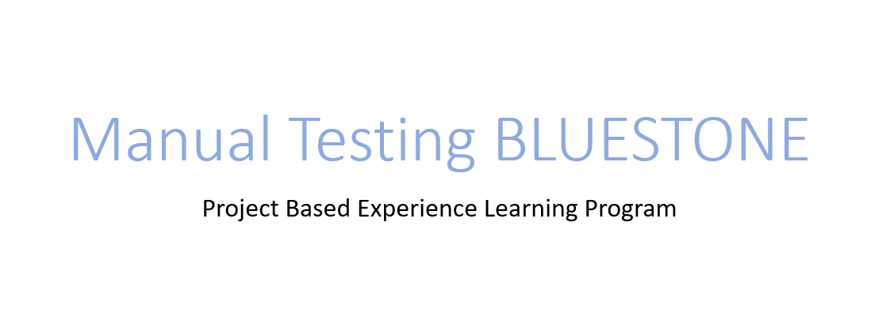



A.M.A.L. COLLEGE, ANAKAPALLE

PROJECT SUBMITTED BY:

TEAM LEADAR: USIRIKA SWATHI

TEAM MEMBER: MALLA REVATHIRERAJU

TEAM MEMBER: RONGALA DURGAPRASAD

TEAM MEMBER: NAKKARAJU SRINU

­­­­­­­­­­­

CERTIFICATE

This to certify that this skill based internship project report submitted in partial fulfillment of requirement for the award of bachelor’s degree in B.Sc. is a bonafide project done Mrs. SWATHI USIRIKA Register No: 720120105171 at his own PC anakapalle he has fulfilled the Mandatory requirements for the award of credits and grade.

DECLARATION

I Mr. USIRIKA SWATHI bearing Reg No: 720120105171 declared that, this skill based internship project report on “SOFTWARE TESTING AUTOMATION” on ITC cut by me at own my PC Anakapalle in fulfillment of the requirement for the award of bachelor’s degree in science this project is original and has been done by me during the period from 17-07-2023 to 24-07-2023.

BLUESTONE Manual Testing

BlueStone is India's leading destination for high quality fine jewellery with strikingly exquisite designs. We aim at revolutionizing the fine jewellery and lifestyle segment in India with a firm focus on craftsmanship, quality and customer experience. In a short span of time, BlueStone has built a large family of loyal consumers in India and abroad.

BlueStone is a web-based e commerce application and it deals with all type of jewellery items and it has both mobile app support for customers to track orders and easy access .

# BLUESTONE HOME PAGE:

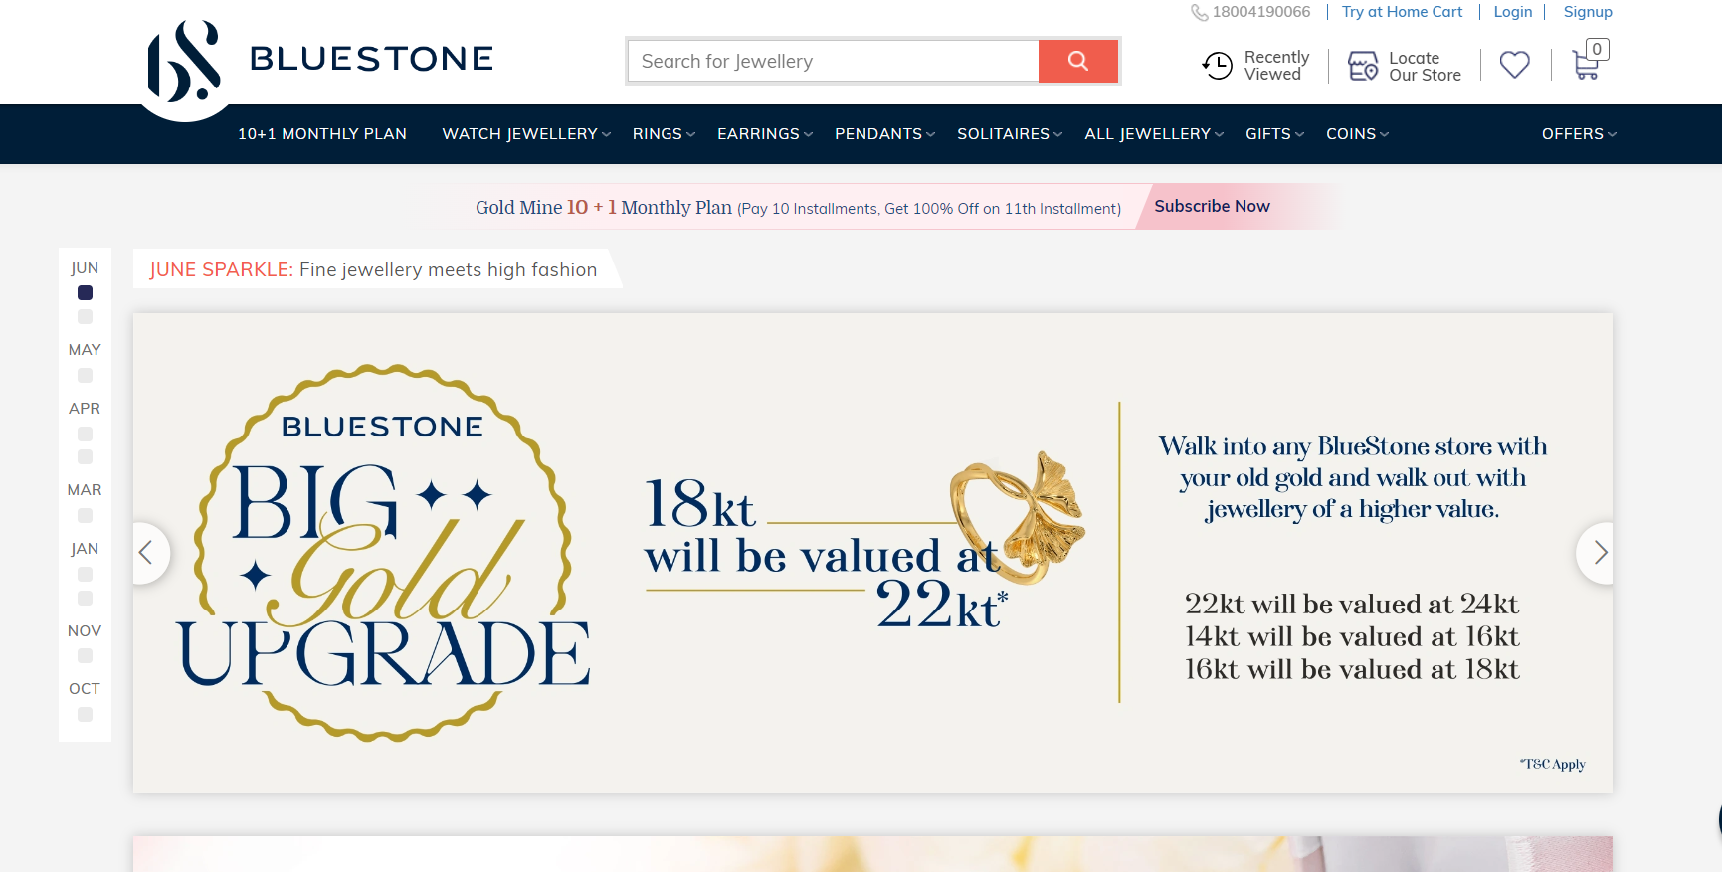

Link: <https://www.bluestone.com>

**Project Flow:**

* User can search the desired product from global search
* User can register once and continue shopping and track items while delivery
* User can get updates on need basis
* User can also continue shopping using mobile app

# Modules Structure:

We have different modules in this all the modules are listed below,

* 10+1 MONTHLY PLAN
* WATCH JEWELLERY
  + Charm
  + Band
  + PIN
* RINGS
  + Popular Rings Types
  + By Price Range
  + By Metals & Stones
* EAR RINGS
  + Popular Earring Types
  + By Price Range
  + By Metals & Stones
* PENDANTS
  + Popular Pendant Types
  + By Price Range
  + By Metals & Stones
* SOLITAIRES
  + Solitaire Rings
  + Solitaire Pendants
  + Solitaire Earrings
  + Save the best model
  + Integrate with Web Framework
* ALL JEWELLERY
  + Shop by Category
  + Men’s Jewellery
  + Kids’ Jewellery
  + Platinum Jewellery
  + Gold Jewellery
  + Gemstone Jewellery
  + Diamond Jewellery
  + Pearl Jewellery
* GIFTS
  + Gift By occasion
  + By Price Range
  + Gifts For Special Someone
* COINS
  + Coins By Purity
  + Coins By Design
  + Silver Coins
* OFFERS
  + Up to 20% Off Making Charges
  + 25% Off Your first Gold Mine Installment
  + All Offers

# Milestone 1: PRODUCT Module

## Activity 1: Gold Mine text verification in terms of color ,font ,spacing between words, design and alignment



Link: <https://www.bluestone.com/goldmine.html?gmfidv=GMS25>

## Activity 2: 10+1 , MONTHLY INSTALLMANET PLAN Text verification in terms of color ,font ,spacing between words, design and alignment



## Activity 3: Verifying other text in terms of color ,font ,spacing between words, design and alignment

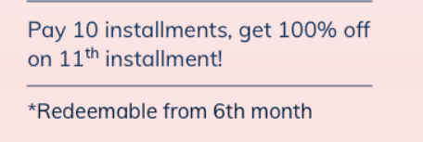

## Activity 4.1: Verifying Monthly amount in terms of color ,font ,spacing between words, design and alignment

## Activity 4.2:Verify user able to enter amount in field and application should accept the user to enter amount

## 

## Activity 4.3:Verify user able to enter some text in amount in field and verify application accepting the user to enter data

## 

## Activity 5.1: Verifying email address and START NOW button color and functionality and below text in terms of color ,font ,spacing between words, design and user able to enter email and verify the functionality of it.

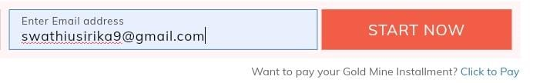

## Activity 5.2: Verifying enter email address field validation when user enter invalid email

# Milestone 2: WATCH JEWELLERY

Under Watch Jewellery for various watches with charm model , Band model, Watch PIN model

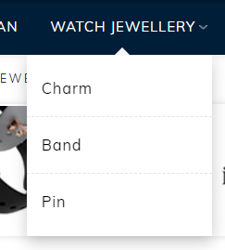

Link: <https://www.bluestone.com/jewellery/watch+jewellery.html>

## Activity 1: Verifying Charm Model in terms of color ,font ,spacing between words, design and whole representation

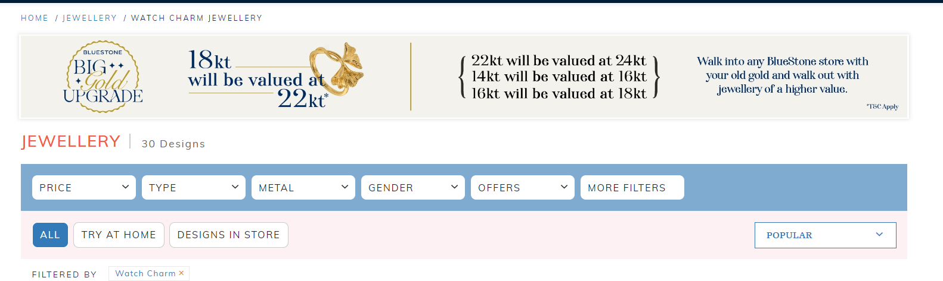

Link: <https://www.bluestone.com/jewellery/watch+charm.html>

## Activity 1.1: Verifying all the text available on screen in terms of color ,font ,spacing between words, design

Verifying various text available on the screen to make sure all data is represented correct

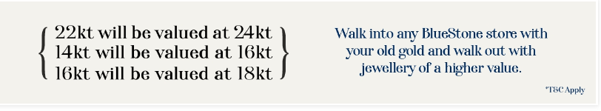

## Activity 1.2: Verifying various filter types once we apply on filter how the application is filtering out results and how the results are loading

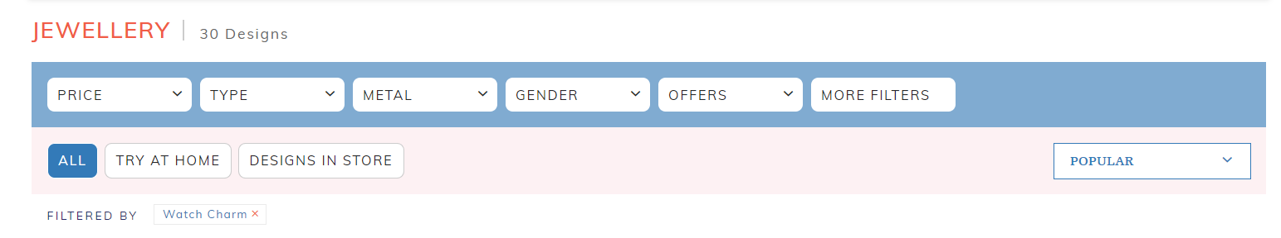

## Activity 1.3: Verifying various images are loading properly and videos are playing when user trying to play it or not related to items

## Verifying the different price for different Items

## 

# Milestone 3: Verifying RINGS module and it’s sub modules

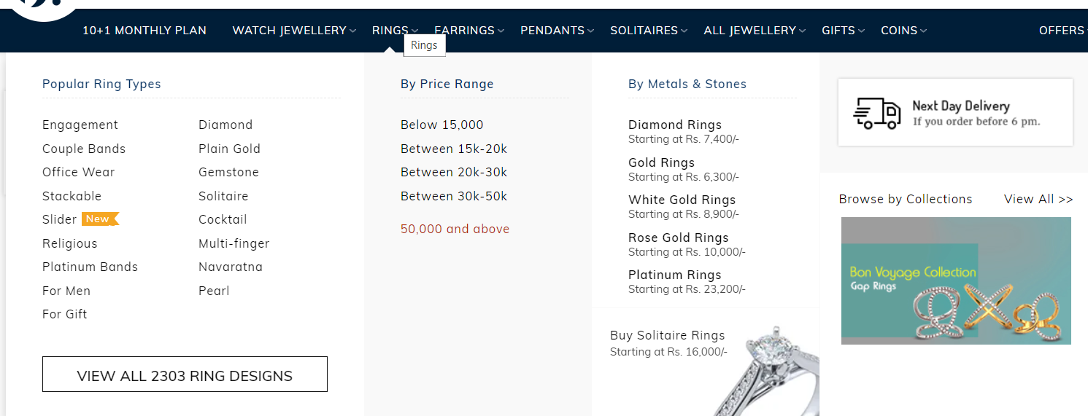

**Link:** [**https://www.bluestone.com/jewellery/rings.html**](https://www.bluestone.com/jewellery/rings.html)

## Activity 1: Verifying Rings sub modules like Popular Ring Types and all links are redirecting to pages or not and all links are clickable and having any tags beside to existing types

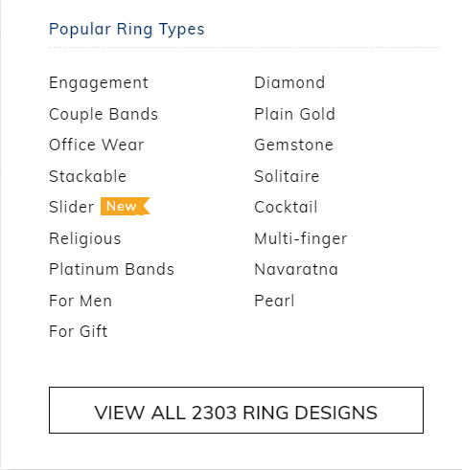

## Activity 2: Verifying link functionalities for each individual sub modules

Verifying each and every sub module links functionality, upon clicking each link is it navigating to desired pages are not

## Activity 2.1: Verifying links are navigating to desired page

In simple words, when user clicks on sub module links it has to navigate to desired link and show the products accordingly

## Activity 2.2: Verifying user able to load more results by clicking on ‘VIEW ALL <<NUMBER>> RING DESIGNS

When User clicks on ‘VIEW ALL <<NUMBER>> RING DESIGNS , it has to load all rings designs available and show images of rings with rates of that particular ring

# Milestone 4: Verifying Signup link functionality

## Activity 1: Verifying user is able to click on Signup link and able to see link on top right corner

## Verify user is able to see color ,font, and words alignment of ‘Signup’ text

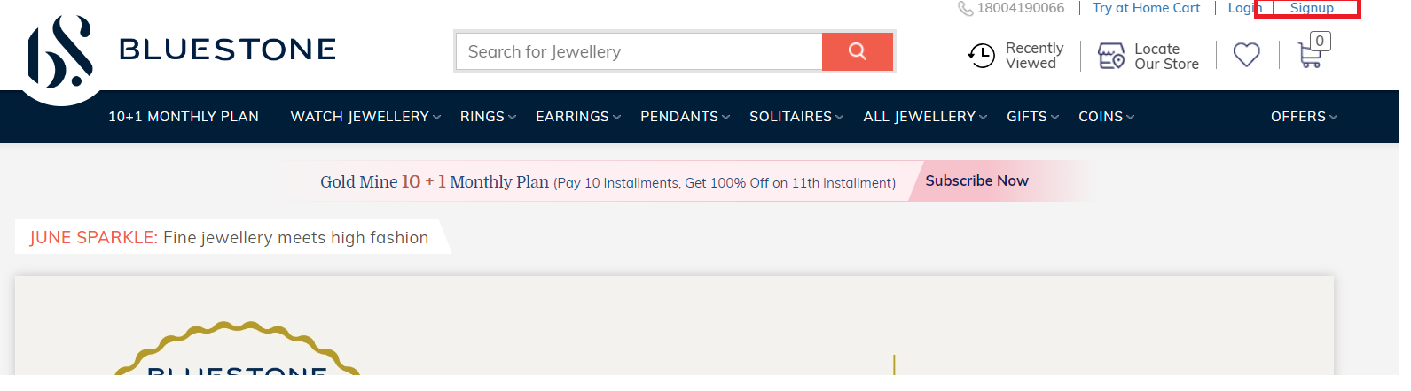

Link: <https://www.bluestone.com/>

## Activity 2.1: Verifying user able to enter all required information in the Signup form and able to complete signup process with all positive and negative data

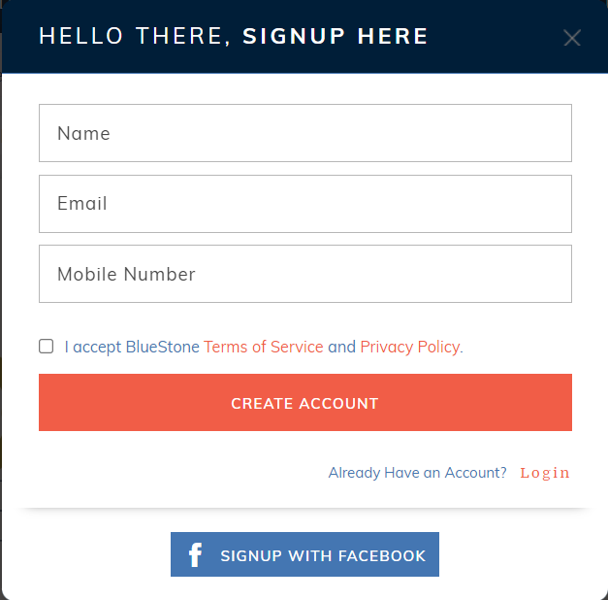

Link: <https://www.bluestone.com/>

## Activity 2.2: Verifying user able to Signup with facebook account if user is having a facebook account

# Milestone 5: Verifying Login link functionality

## Activity 1: Verifying user is able to click on Login link and able to see link on top right corner

## Verify user is able to see color ,font, and words alignment of ‘Login text

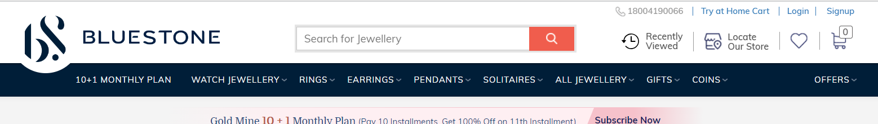

Link: <https://www.bluestone.com/>

## Activity 2.1: Verifying user able to enter all required information in the Login form and able to login successfully with all positive and negative data

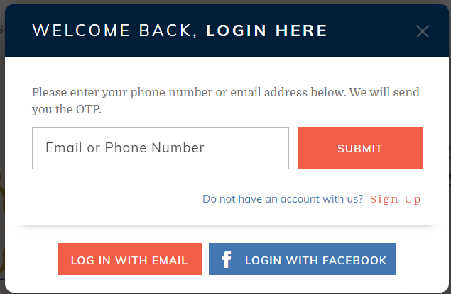

Link: <https://www.bluestone.com/>

## Activity 2.2: Verifying user able to login with email account in the Login form and able to login successfully with all positive and negative data

## 

Link: <https://www.bluestone.com/>

**Final Testing Areas:**

1. Test the Home page elements color, font, alignment, design
2. Test the global search
3. Test the Try Home Cart , Login, Signup link functionality
4. Test the recently viewed ,Locate store, favorites, Cart functionality
5. Test each and every module and sub module functionality is it navigating to desired page
6. Test videos related to jewellery items playing correctly or not
7. Test price for each item
8. Test filters to load results is correctly working or not
9. Test all dropdowns are correctly loading the results
10. Test loading results from dropdown are accurate or not
11. Test browser compatibility
12. Test user is able to navigate to Top section when user at bottom by clicking on TOP button
13. Test user is able to chat with executive

PHOTO

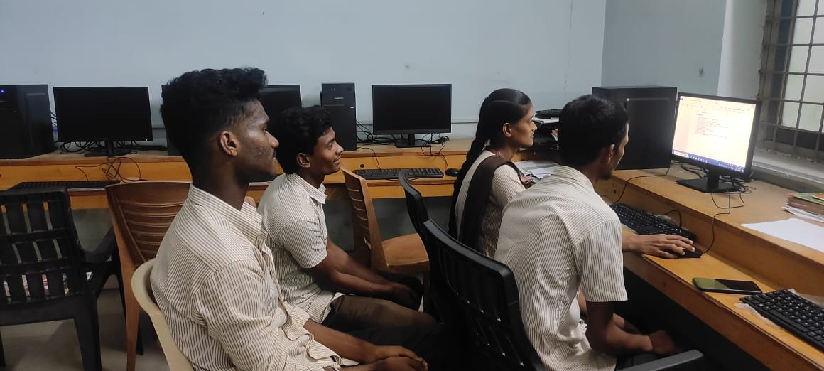

DOING GROUP PROJECT WORK